Assignment

- What is Exception? Write a program for exception handling?

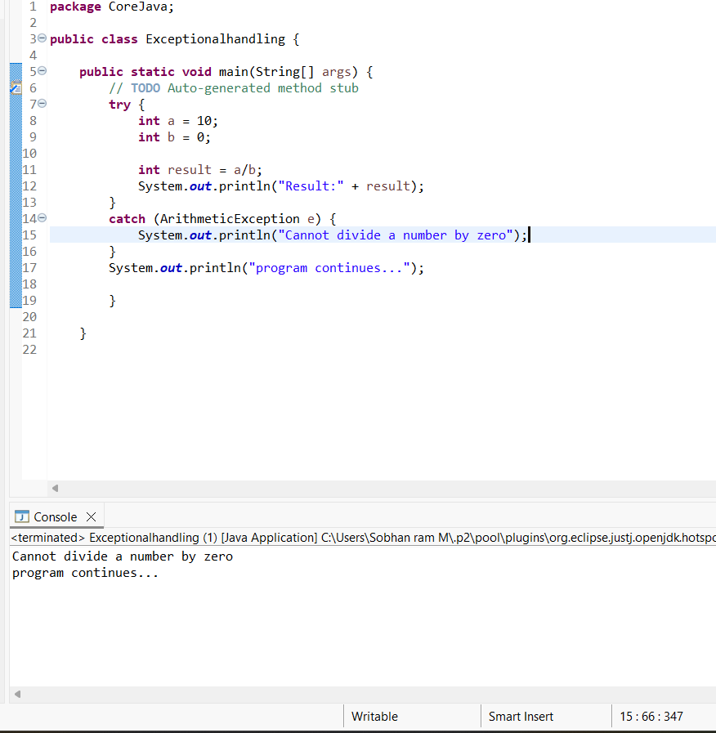
What is an Exception?
An Exception is an unwanted or unexpected event that occurs during the execution of a Java program and disturbs the normal flow of the program.
Common examples of exceptions:
- Dividing a number by zero → ArithmeticException
- Accessing an invalid array index → ArrayIndexOutOfBoundsException
- Using a null object → NullPointerException
- Entering invalid input → InputMismatchException
Exception Handling
Exception handling is a mechanism used to handle runtime errors so that the program does not terminate unexpectedly.
Java mainly uses these keywords:
- try → Contains code that may cause an exception.
- catch → Handles the exception.
- finally → Executes whether an exception occurs or not.
- throw → Used to explicitly throw an exception.
- throws → Declares an exception that a method may generate.

try → Try the risky code
catch → Catch the error
finally → Finally execute

(Exam definition
Exception is an abnormal event that occurs during the execution of a Java program and disrupts the normal flow of the program. Exception handling is used to handle such errors using try, catch, finally, throw, and throws keywords.)

- 2) What is Collections? Write a program to remove duplicate names using Collections

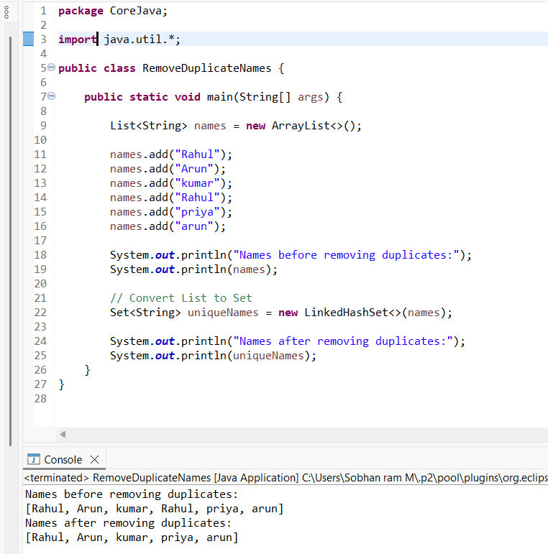
Collection is a framework in Java used to store and manipulate a group of objects. To remove duplicate names, we can use a Set because Set does not allow duplicate elements.

import
import is a Java keyword used to bring classes or interfaces from another package into your program.
Instead of writing the full package name every time, we can simply use the class name.

2. java
java is the top-level package name provided by Java.
Java has many built-in packages.
For example:
java.lang
java.util
java.io
java.sql

3. util
util means utility.
java.util is a package containing many useful classes for working with data and collections.
For example:
List
ArrayList
Set
HashSet
LinkedHashSet
TreeSet
Map
HashMap
Scanner

4. *
The * means all classes and interfaces inside java.util.
So:
import java.util.*;
means:
"Import all the classes/interfaces available in the java.util package that my program needs."

Example
Without the import:
java.util.List<String> names = new java.util.ArrayList<>();
This works, but it is lengthy.
With:
import java.util.*;
we can simply write:
List<String> names = new ArrayList<>();
In your program
You are using:
List<String> names = new ArrayList<>();
and:
Set<String> uniqueNames = new LinkedHashSet<>(names);
All of these come from java.util.
So this single line:
import java.util.*;
allows you to use them without writing java.util repeatedly.
Easy way to remember
import → Bring something into the program
java → Java's package
util → Utility package
* → All available classes/interfaces
One small note: * does not mean every class from every Java package. It only imports classes from java.util.

